Inheritance:

http://www.tutorialspoint.com/java/java_inheritance.htm

**Note:**A subclass inherits all the members (fields, methods, and nested classes) from its superclass. Constructors are not members, so they are not inherited by subclasses, but the constructor of the superclass can be invoked from the subclass

If a class is inheriting the properties of another class, the subclass automatically acquires the default constructor of the super class.

class Superclass{

int age;

Superclass(int age){

this.age=age;

}

public void getAge(){

System.out.println("The value of the variable named age in super class is: " +age);

}

}

public class Subclass extends Superclass {

Subclass(int age){

**super(age);**

}

public static void main(String argd[]){

Subclass s= new Subclass(24);

s.getAge();

}

}

**IS-A Relationship:**

If a class extends another class “completely” than a subclass “is-a” superclass.

//Animal is the superclass of Mammal class

Public class Animal{}

Public class Mamal extends Animal{}

## HAS-A relationship

public class Vehicle{}

public class Speed{}

public class Van extends Vehicle{

private Speed sp;

}

//This shows that class Van HAS-A Speed.

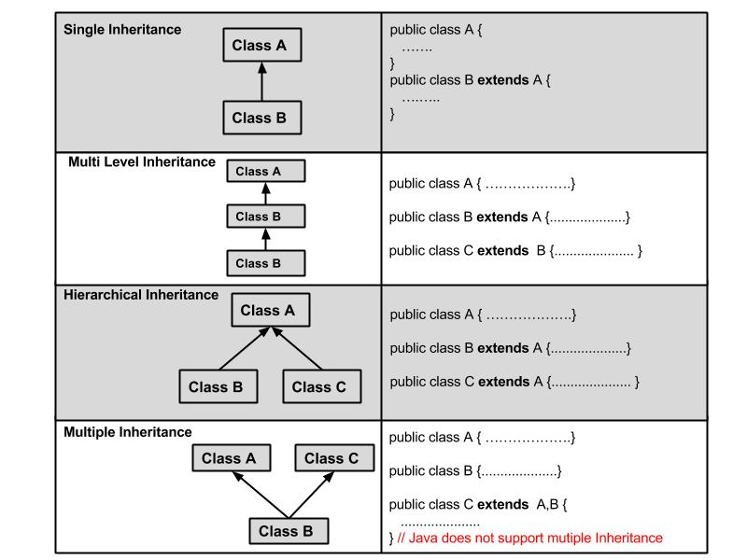

1Types of inheritance: